About Hong Kong
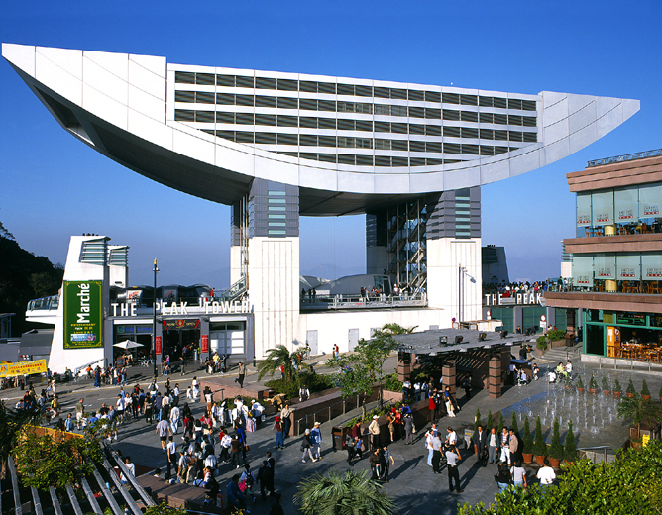
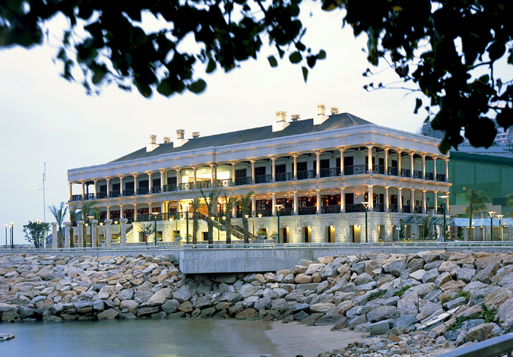
Hong Kong is one of the most dynamic cities on Earth, and a unique combination of more than 150 years of colonial influence and 5,000 years of Chinese tradition. There is so much to see and to do that it would take several visits to experience it all.

The Victoria Peak – the perfect location for a panoramic view of Hong Kong.
Stanley – a popular market town for both locals and visitors on the sunny south side of Hong Kong Island, Stanley’s relaxed ambience, crisp sea environs and bargain buys have made it world famous.
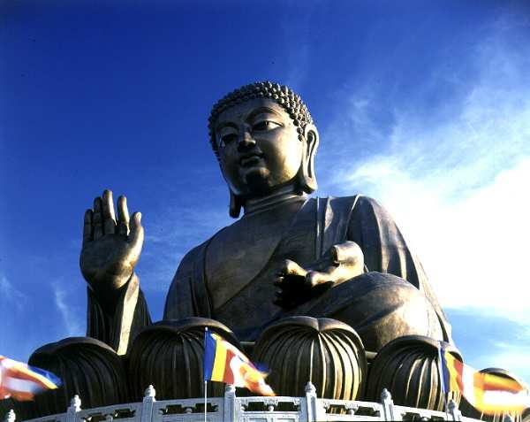
Temple Street Night Market – the market which comes alive after sunset. It offers an amazing range of inexpensive items for men and women. There are also fortune tellers and impromptu Chinese opera performances.
Giant Buddha/Po Lin Monastery – the world’s largest seated, outdoor, bronze Buddha sits serenely amid the mountain scenery of Lantau Island.

Theme Parks – The newest Disneyland and Ocean Park will give you memorable experiences.
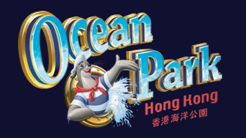

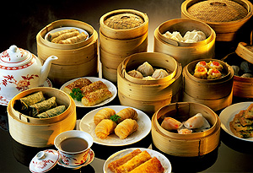
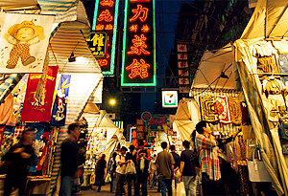
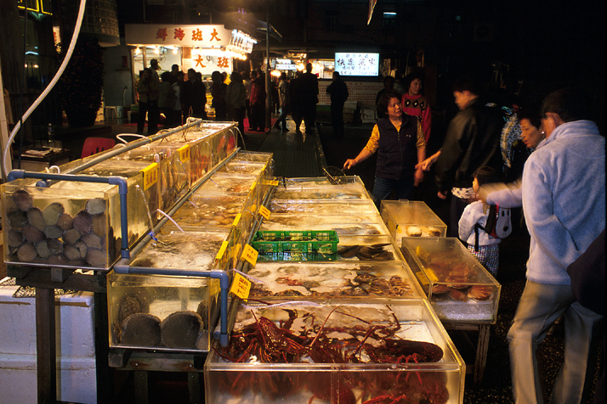
Also known as the culinary capital of Asia, the restaurants here provide a mouth-watering choice of dining options including regional Chinese specialties, signature dishes, various Asian delicacies and numerous Western cuisines. The city’s shops and malls as well as open air street markets feature an awesome variety of the latest cutting edge products.

For more details, please visit the Hong Kong Tourism Board’s website: http://www.discoverhongkong.com

Entry Regulations
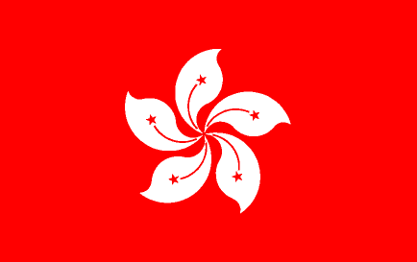
All visitors to Hong Kong must have a travel document, which must be valid for at least one month beyond the planned departure date from Hong Kong. Most countries can enter Hong Kong without a visa for periods up to six months, depending on their nationality. If visa is required, application should be made at the nearest Chinese Embassy, Consulate or Visa office, or check out the Hong Kong Immigration Department’s website http://www.immd.gov.hk/ for full details of passport and visa requirements.

Banks and currency
Major banks are usually open from 9 am to 4:30 pm, Monday to Friday and 9 am to 12:00 noon on Saturday. Automated-Teller Machines (ATMs) can be found almost everywhere, providing 24-hour cash (in HK$) withdrawal facilities for Visa and Master card holders. The currency of Hong Kong is the Hong Kong dollar. The dollar has been pegged at approximately HK$7.8 to the US dollar, and consequent rates of exchange to other currencies. Credit cards and traveler cheques are widely accepted.

